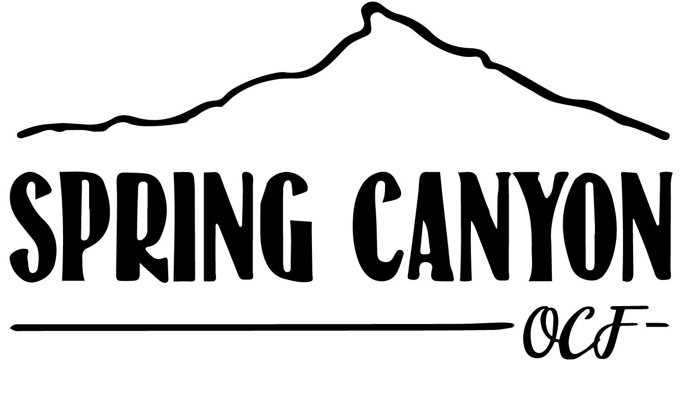

FALL & SPRING RETREATS
SUGGESTED PACKING LIST
This list will help you pack for Fall and Spring Retreats at Spring Canyon. Spring Canyon is located at over 9,000 feet in elevation and weather will vary during your stay. Daily temperatures can range from below zero to 60 degrees. We are located closer to the sun than you may be accustomed; sunscreen and sunglasses are highly recommended. The following list contains suggested items in addition to your personal packing list to ensure you get the most out of your time in Colorado.

- Weekly toiletries (shampoo, conditioner, toothpaste, etc.)
- Prescription meds
- Baseball cap or visor
- Sunscreen and lip balm
- Sunglasses
- Flashlight or headlamp
- Hiking boots or athletic shoes
- Outdoor boots (suitable for cold/snowy conditions)
- Clothing layers (fleece or sweatshirt midlayer; puffy or external jacket; waterproof outer layer)
- Wool socks
- Warm hat
- Warm waterproof gloves
- Water bottle
- Swimsuit (if planning to go to Hot Springs)
- Bible, pen, and paper
- Backpack or daypack

If you have any questions about the above suggested items, please contact Spring Canyon.
We look forward to seeing you. Welcome home!

